**SCIT**

**School of Computing and Information Technology Faculty of Engineering & Information Science**

**CSIT321 - Project**

**Project Topic: TripAid based on LOLs**

|  |  |  |
| --- | --- | --- |
| **Project Requirement Documentation** | | |
| **Version 2.0** | | |
| **05/05/2022** | | |
| **Group:** | **FYP-22-S2-29P** | |
| **Student Name** | **UOW Student ID** | **Email** |
| Chong Hui Wen | 7311436 | hwchong002@mymail.sim.edu.sg |
| Chen Jingguo | 7311709 | jchen120@mymail.sim.edu.sg |
| Ho Bing Yuan | 7224278 | byho001@mymail.sim.edu.sg |
| Viswanadham Udaya Chitanya Krishna | 7083270 | viswanad004@mymail.sim.edu.sg |
| Wong Teck Yong | 7061560 | tywong007@mymail.sim.edu.sg |
|  | **Supervisor** | Premarajan |
|  | **Assessor** | Dr Loo Poh Kok |

Project Website: https://fyp22s229.blogspot.com/

**Document Version Record**

|  |  |  |  |
| --- | --- | --- | --- |
| **Version** | **Date** | **Description** | **Author** |
| 1.0 | 17/04/2022 | 1st draft | Huiwen  Jingguo  Teck Yong  Bing Yuan  Krishna |
| 2.0 | 05/05/2022 | 2nd draft | Huiwen  Jingguo  Teck Yong  Bing Yuan  Krishna |

**1.** **Introduction** 5

1.1 Executive Summary 5

1.2 Project Scope 5

1.3 Project Description 5

1.4 Target Audience 6

1.5 Business Model 6

**2.** **Research Finding Analysis** 7

2.1 Product Comparison 7

2.1.1 **Visit Singapore** 7

2.1.2 **Tripadvisor** 9

2.1.3 **Visit A City** 10

2.1.4 **Klook** 11

2.1.5 **KKday** 12

2.1.6 **GetYourGuide** 13

**2.2 Comparison of Similar Platforms** 14

**2.3 Rationale Table** 18

**3.** **Project Motivation** 21

4. Functional Requirements 22

4.1 Functional Hierarchy 22

4.2 Use Case Diagram 27

4.2.1 User 27

4.2.2 Administrator 28

4.2.3 Business Owner 29

4.3 Use Case Description 30

4.3.1 All Actors 30

4.3.2 User, Business Owner, LOL 32

4.3.3 User 33

4.3.4 LOL 56

4.3.4 Administrator 59

4.3.5 Business Owner 80

**5.** **Proposed Plan** 82

5.1 Execution Strategy 82

5.2 Software Development Method 82

5.2.1 Waterfall Model 82

5.2.2 Agile 84

5.3 Risk Analysis 87

5.4 Project Schedule 88

**6.** **Roles and Responsibilities** 96

**7.** **Development Tools** 97

7.1 Flutter 97

7.2 Firebase 98

7.3 Others 99

**8.** **Expected Results** 100

**9.** **Conclusion** 100

References 101

# **Introduction**

## 1.1 Executive Summary

This proposal describes briefly with regards to a project in which a native application in iOS and Android will be developed for travellers exploring Singapore. In this document, Introduction gives an overview of the project, Project Description provides more details and insights such as the objective and background of the project, along with the expected development methods, breakdown of the roles and responsibilities for the team involved and a scheduled timeline through the entire project phase.

## 1.2 Project Scope

This proposal will discuss a project in developing a native iOS and Android application, to enhance the user experience for travellers navigating around Singapore, by providing elevated functionalities on top of existing travel apps, recommending curated walking routes, recommending interesting sights and written guides all in one nifty app. The project consists of research on the various travel applications in the market, exploring the functionalities the applications have that makes it compelling for the users, areas which can be improved on and implementing those new functions that will attract more users.

## 1.3 Project Description

Travelling and exploring new places has been a favourite pastime of many people. Before the widespread use of the internet and technology, many people referred to travel guides on TVs and guidebooks to check on the recommended places to visit in a country.

With the widespread use of technology, there has been an increase in the number of user-generated content, blogs, videos, and information about various places of interest around the world. These user-generated contents allow users to read the different reviews of the places from people around the world. Many people have since then researched their itinerary and even booked flight tickets online.

With the aim of our project being to develop a mobile application as an encyclopaedia about Singapore and its landmarks, we want our users to be able to readily access information and reviews at the touch of their fingertips, aiding them in the planning of their next trip to Singapore. Additionally, the team plans to include a forum feature to bring about a social aspect of this application.

## 1.4 Target Audience

The target audience of the applications are business owners, Local Opinion Influencers (LOLs), tourists and locals.

## 1.5 Business Model

The team plans to provide a software as a service, to provide businesses and users a platform to advertise and promote themselves to locals and tourists through this application.

The business model of the application is to charge advertising fees to its users, such as business owners and Local Opinion Influencers (LOLs).

For example, business owners can submit articles and promote their business on the platform to raise awareness on their company and its offerings. For LOLs, they can also publish travel guides and itineraries on the different locations in Singapore, increasing their social outreach.

A distinctive feature of the application is the forum. As a forum is a social platform, users can share, discuss various topics and interests with other users. This social platform helps to create a community among the users, which in turn allows the user to use the application often to interact with other users.

# **Research Finding Analysis**

## 2.1 Product Comparison

### 2.1.1 **Visit Singapore**

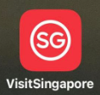

An app designed specifically for tourists in Singapore to navigate and plan their itinerary. Allows travellers to locate places of interest on the go, create and customize your day-to-day itinerary, get information on travel essentials and be updated on recent events and happenings.

**Functionalities:**

* Account: Personal profile creation, customizable profile picture and account details
* My Trip: Save place of interest and create itinerary
* Discover: Popular place of interest shown based on category
* Search: Ability to search for relevant content within application
* Review System: Review and rating by users in certain posts
* Money Changers: Display money changers available in Singapore
* Map: Display distance require from user’s current location to point-of-interest
* Useful Contacts: Shows the tourist hotline, police hotline, ambulance & fire brigade hotline and embassy contacts
* Handy Tips: Additional tips for travellers to read for smoother transition in Singapore
* Guides: Concentrates on certain area of interest in Singapore
* What’s Near You: Display services located nearby user’s current location
* Social Sharing: Able to share itinerary saved by user in PDF format
* Offline Viewing: Itinerary in downloadable PDF format allows viewing of itinerary without the need of internet connectivity

### 2.1.2 **Tripadvisor**



An American online travel company’s mobile application that offers online hotel reservations and bookings for transportation, lodging, travel experiences, and restaurants.

**Functionalities:**

* Account: Personal profile creation, customizable profile picture and account details
* Plan: Save place of interest and create itinerary, invite others to view itinerary
* Explore: Suggestions by application of place of interest
* Search: Dedicated search tab to search for relevant content within application
* Review & Rating System: Review and rating by users in certain posts
* Viewing Of Other Users: Ability to view other user’s profile and their reviews, with options to follow or message user
* Forum: Users can post and reply for discussion on relevant topic
* FAQ: Q&A section in the post itself, where users can post queries and other users can answer
* Map: Shows the location of the place of interest in the map view
* Nearby: Display services located nearby user’s current location
* Booking Of Interest: Allows user to book certain place of interest via the application itself
* Currency Changer: Users may view restaurants in different kind of currencies
* Unit measurements: Interchangeable between Kilometres and Miles
* Social Sharing: Able to share place of interest to other social platforms

### 2.1.3 **Visit A City**



Visit A City offers users adjustable guides to allow them to have the flexibility to plan their itineraries, with a wide range of popular sights, tours, and attractions.

**Functionalities:**

* Account: Personal profile creation
* Plan: Recommends standard/fixed itinerary in certain places
* Search: Search bar to look for a destination
* Wishlist: User can save certain posts
* Review & Rating System: Review and rating by users
* Map: Shows the location of the place of interest in the map view
* Navigation: Uses Apple Maps/Google Maps/Waze to guide user to place of interest
* Nearby: Display services located nearby user’s current location
* Booking Of Interest: Allows user to book certain place of interest via the application itself
* Currency Changer: Able to change currency to desired ones within the post itself
* Social Sharing: Able to share place of interest to other social platforms
* Offline Viewing: Downloadable content for no internet connectivity viewing
* Contact Us: Feedbacks to application owner available via redirection to their website

### 2.1.4 **Klook**



World-leading travel activities and services booking platform with more than 60,000 activities across 250 major destinations, Klook aims to provide travellers a seamless way to discover and book popular attractions, local tours, rail passes, food options, airport transfers, and unique experiences around the world.

**Functionalities:**

* Account: Personal profile creation, customizable profile picture and account details
* Search: Search bar to look for a destination/place of interest
* Wishes: User can save certain posts
* Review & Rating System: Review and rating by users
* Map: Shows the location of the place of interest in the map view
* Navigation: Uses Apple Maps/Google Maps to guide user to place of interest
* Booking Of Interest: Allows user to book certain place of interest via the application itself
* Currency Changer: Able to change currency to desired ones for the entire application
* Social Sharing: Able to share place of interest to other social platforms
* FAQ: FAQ of posts and application available
* Filters: Filter/sort posts according to user’s preference
* Payment Method: Multiple payment options to choose from
* Shopping Cart: Add multiple destination to cart before checking out

### 2.1.5 **KKday**



A travel e-commerce platform where people can get their travel needs. All you have to do is to pick a destination and plan the journey with KKday’s variable selections. Over 30,000+ experiences and travel essentials all in one application, KKday.

**Functionalities:**

* Account: Personal profile creation, customizable profile picture and account details
* Search: Search bar and tab to look for a destination
* Wishlist: User can save certain posts
* Review & Rating System: Review and rating by users
* Map: Shows the location of the place of interest in the map view
* Navigation: Uses Apple Maps/Google Maps/Waze to guide user to place of interest
* Booking Of Interest: Allows user to book certain place of interest via the application itself
* Currency Changer: Able to change currency to desired ones for the entire application
* Social Sharing: Able to share place of interest to other social platforms
* Filters: Filter/sort posts according to user’s preference
* Chatbot: Post have a chatbot for user to enquire with
* Payment Method: Multiple payment options to choose from
* Feedback: Option to feedback to application developer

### 2.1.6 **GetYourGuide**



GetYourGuide offers users to easily find and book top rated tours, activities and excursions with 24/7 customer service to assure users when booking their tickets.

**Functionalities:**

* Account: Personal profile creation, customizable account details
* Discover: User can see recommended destinations
* Search: Search bar to look for a destination
* Wishlist: User can save certain posts
* Review & Rating System: Review and rating by users
* Map: Shows the location of the place of interest in the map view
* Navigation: Uses Apple Maps/Google Maps/Waze to guide user to place of interest
* Nearby: Search for destination and sort by distance to see nearby interest
* Booking Of Interest: Allows user to book certain place of interest via the application itself
* Currency Changer: Able to change currency to desired ones for the entire application
* Social Sharing: Able to share place of interest to other social platforms
* Filters: Filter/sort posts according to user’s preference
* Feedback: Option to feedback to application developer
* Live Chat: User can chat with customer service at any time of the day
* Application Appearance: User can choose dark or light theme

## **2.2 Comparison of Similar Platforms**

|  |  |  |  |  |  |  |  |
| --- | --- | --- | --- | --- | --- | --- | --- |
| Functions | VisitSingapore | Tripadvisor | Visit A City | Klook | Kkday | GetYourGuide | SGTours |
| Android & iOS compatible | Yes | Yes | Yes | Yes | Yes | Yes | Yes |
| Creation of Account/Personal Profile | Yes | Yes | Yes | Yes | Yes | Yes | Yes |
| Update Profile | Yes | Yes | Yes | Yes | Yes | Yes | Yes |
| Viewing of other user's profile and review | No | Yes | No | No | No | No | Yes |
| Social Media Sharing | Yes, sharing of plan/itinerary only | Yes, sharing of posts | Yes, sharing of posts | Yes, sharing of posts | Yes, sharing of posts | Yes | Yes |
| Manage Comment in Forum | No | Yes | No | No | No | No | Yes |
| Add Rating and Review | No | Yes | No | No | No | No | Yes |
| Nearby me | Yes | Yes | Yes | No | No | Yes, sort by distance | Yes |
| Booking of interest directly from application | No | Yes (certain places) | Yes | Yes | Yes | Yes | No |
| Save location of interest | Yes | Yes | Yes | Yes | Yes | Yes | Yes |
| Search tab/bar to find anything | Yes | Yes | Yes | Yes | Yes | Yes | Yes |
| Currency converter | Yes | No | No | No | No | No | Yes |
| Change currency of posts | No, no prices stated on posts | Yes, change currency of entire app | Yes | Yes, change currency of entire app | Yes | Yes, change currency of entire app | No |
| Change unit measurements | No | Yes, Kilometres/Miles | No | No | No | No | No |
| Offline viewing | No | No | Yes | No | No | No | Yes |
| Trip itinerary | Yes | Yes, can invite people to view itinerary | Yes | Yes | Yes, Orders | Yes | Yes |
| Submit Feedback | Yes | Yes | Yes, Contact Us | No | Yes | Yes | Yes |
| Report vulnerability | Yes | No | No | No | No | No | No |
| Chatbot/Live Chat | No | No | No | No | Yes | Yes | No |
| Local Emergency Services System | Yes, Useful Contacts | No | No | No | No | No | Yes |
| Map that shows location of interest | Yes | Yes | Yes | No | Yes | Yes | Yes |
| Navigation Map | Yes | No | Yes, certain posts only | No | Yes | Yes | Yes |
| Sort filters by relevant/date/popularity/price | No | Yes | No | Yes | Yes | Yes | Yes |
| Dark/Light mode | No | No | No | No | No | Yes | No |
| Verification Badge | No | No | No | No | No | No | Yes |
| Local Opinion Leaders/Influencer sharing | No | No | No | No | No | No | Yes |

## **2.3 Rationale Table**

|  |  |  |
| --- | --- | --- |
| **Functions** | **To Implement?** | **Rationale** |
| Android & iOS compatible | Yes | * Outreach to more users due to availability in both operating systems |
| Creation of Account/Personal Profile | Yes | * Uniquely identified users in SGTours |
| Update Profile | Yes | * To update their profile details after creation |
| Viewing of other user’s profile and review | Yes | * Allow users to check the reliability of other user’s reviews or to see what else other users have reviewed |
| Social Media Sharing | Yes | * Convenience sharing to other social platforms for users * Free advertisement for SGTours |
| Manage Comment in Forum | Yes | * A place for users to hold discussion * Sharing of experience with other users * Users may possibly find their answers to their query through the forum |
| Add Rating and Review | Yes | * Able to give feedback to the interest based on experience, with satisfactory level from user * Sharing of experience with other users |
| Nearby Me | Yes | * Shows what services/places-of-interest are nearby user’s current location |
| Save location of interest | Yes | * Users can revisit the place of interest without the need to search again |
| Search tab/bar to find anything | Yes | * User can find place of interest quickly without going through a series of categories |
| Currency converter | Yes | * User can find out how their own currencies will fare when exchanged with foreign currencies without the need of another application |
| Offline Viewing | Yes | * Allows user to download offline viewing for maps, guides, and places-of-interest before not having any internet access when coming to Singapore * If users are in places with weak/no internet access (MRT underground, etc), users will still be able to view |
| Trip itinerary | Yes | * Helps user to plan how they travel from different places-of-interest and manage their time |
| Submit Feedback | Yes | * Developers can know what function or features to improve on based on users experience with SGTours * Receive reports of bug |
| Local Emergency Services System | Yes | * By tapping on the phone number, the user will be redirected to the dial page with the phone number entered. |
| Map that shows location of interest | Yes | * Without the need to search up on the location in another application, users will know location of interest via the map in SGTours |
| Navigation Map | Yes | * Allow users to navigate their way from their location to their desired places-of-interest |
| Sort filters by relevant/date/popularity | Yes | * Different views that user can view their results in |
| Verification Badge | Yes | * Trusted/Reliable users that other users can very likely take reference with |
| Local Opinion Leaders/Influencer sharing | Yes | * LOLs can share their itinerary guides with SGTours users * LOLs can share their experience through forum with other users * Potentially influencing other users from other platforms to sign up with SGTours |
| Booking of interest directly from application | No | * To redirect users to their official website so that we don’t have to keep update any new deals/promotion * Booking queries will be answered via their official websites |
| Change currency of posts | No | * Posts will not have price indicated since SGTours are redirecting purchases to official merchant website |
| Change unit measurements | No | * Unit measurements should not be an issue for most users as Singapore adopts the International System of Units |
| Report vulnerability | No | * Can be done via submitting feedback |
| Dark/Light mode | No | * Potentially ruining the application theme/UI |
| Chatbot/Live Chat | No | * Application will include an FAQ page * Any other question can be asked through forum |

# **Project Motivation**

Currently, there are various travel mobile applications that provide basic functionalities in guiding tourists/locals around Singapore. As such, with many options available in the markets, users might often find themselves unsure on which app to use or having to reference two or even more applications for a more accurate representation and certain functionalities. This takes up a lot of time and effort and can be very frustrating often as different applications might recommend different choices.

As such, SGTours hopes to be the top choice of users with all such functionalities integrated in an application that will prioritise and recommend users to the best of their preferences, navigating them to their destination with a pleasant user experience and even providing additional functionalities to make it more compelling.

# Functional Requirements

## 4.1 Functional Hierarchy

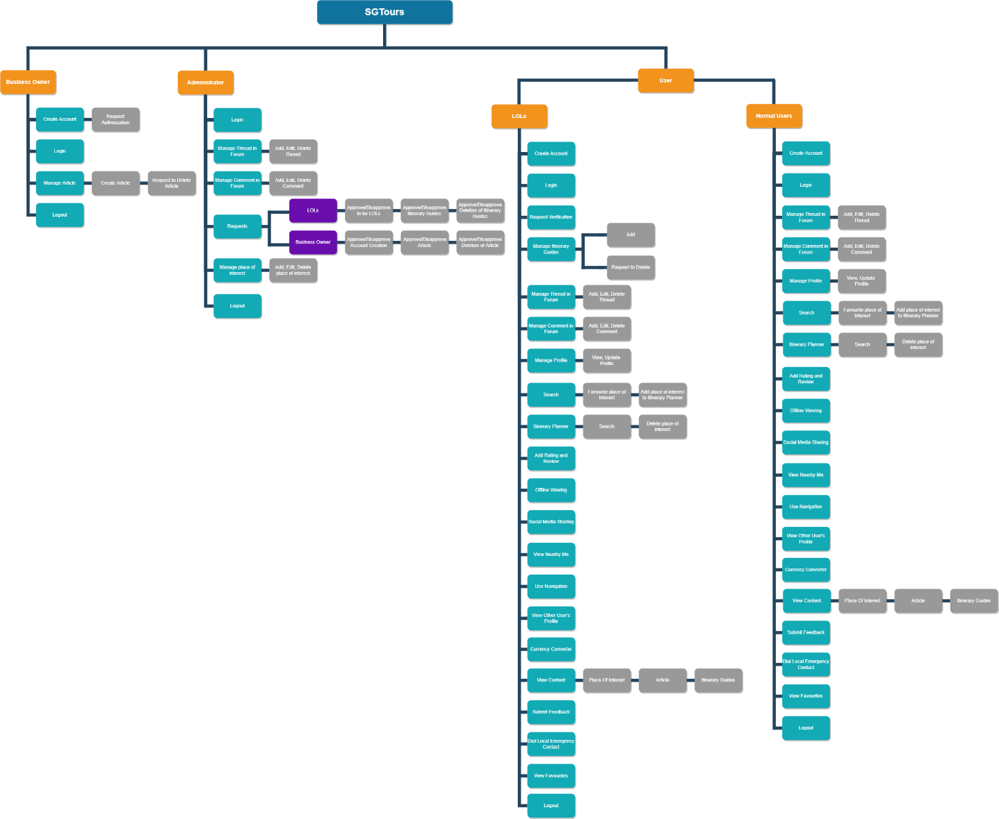

Business Owner

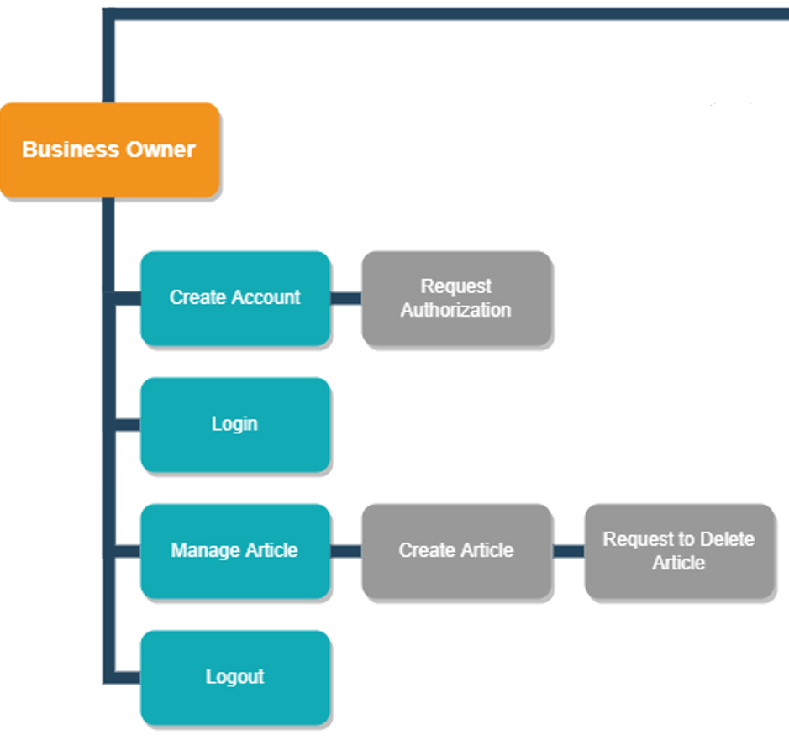

Administrator:

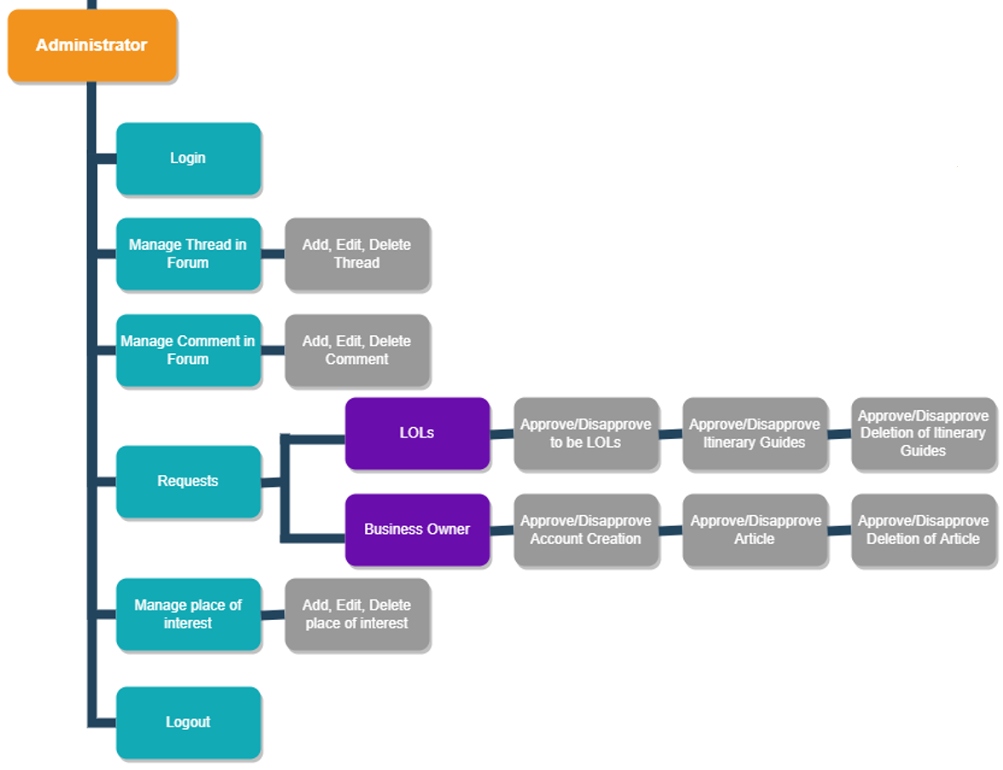

LOLs & Normal User:

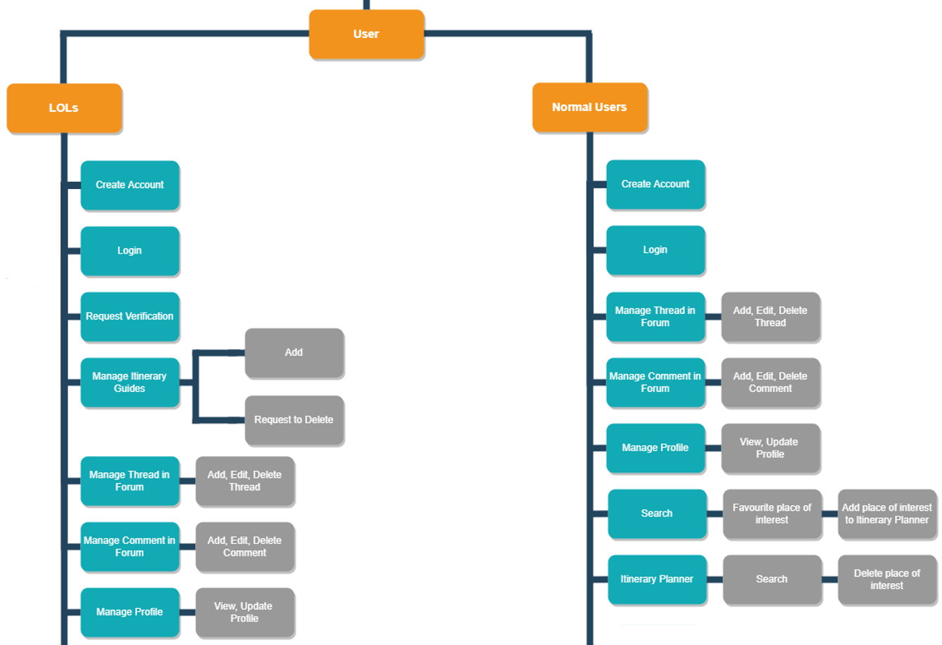

LOLs & Normal User:

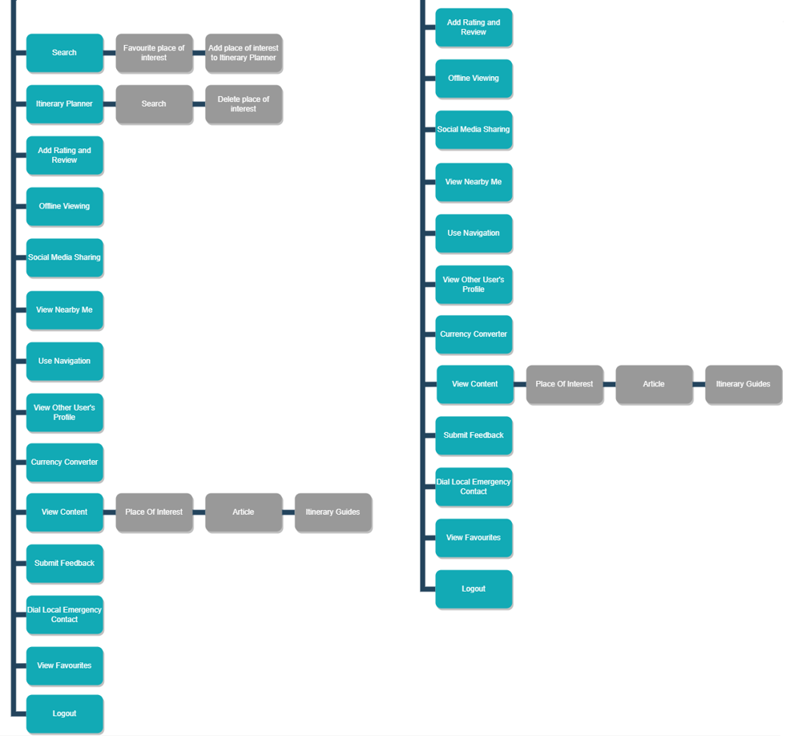

### 4.2 Use Case Diagram

### 4.2.1 User

### 4.2.2 Administrator

### 4.2.3 Business Owner

## 4.3 Use Case Description

### 4.3.1 All Actors

|  |  |
| --- | --- |
| **Name:** **Login** | **ID: #001** |
| **Stakeholders and Goals:** User, Administrator, Business Owner, LOL - Valid Account Holders want to login successfully | |
| **Description:** Valid Account holders want to access the application features after they login with their user credentials at Login page | |
| **Actors:** User, Administrator, Business Owner, LOL | |
| **Trigger:** Account Holders tap on “Login” button | |
| **Normal Flow:**   1. Application will prompt account holder for their registered username and password. 2. Account Holder inputs the details and taps on the login button to submit. 3. Application will check if account records exist against database records. 4. Application verifies the account holder and allows the account holder into the application. 5. Account holder will be greeted with the home page of the application. 6. End. | |
| **Sub-Flows:** None | |
| **Alternative/Exceptional Flows:**  3a. Incorrect Username/Password: Application will prompt account holders to enter the correct username and password | |

|  |  |
| --- | --- |
| **Name:** **Logout** | **ID: #002** |
| **Stakeholders and Goals:** User, Administrator, Business Owner, LOL - Account Holder can successfully logout of the Application | |
| **Description:** Account Holders want to end the current session and logout of the application | |
| **Actors:** User, Administrator, Business Owner, LOL | |
| **Trigger:** Account Holders taps on “Logout” button | |
| **Normal Flow:**   1. Account Holder taps on the logout button. 2. Application will end the session and direct them to the login page. 3. End. | |
| **Sub-Flows:** None | |
| **Alternative/Exceptional Flows:** None | |

### 

### 4.3.2 User, Business Owner, LOL

|  |  |
| --- | --- |
| **Name:** **Create account** | **ID: #003** |
| **Stakeholders and Goals:** User, LOL, Business Owner - create an account successfully | |
| **Description:** A User/LOL/Business Owner wants to create an account | |
| **Actors:** User, LOL, Business Owner | |
| **Trigger:** User/LOL/Business Owner taps on “Register” button | |
| **Normal Flow:**   1. User/LOL/Business Owner will enter their username, password, and email. 2. Application will check if the account is registered before against database records. 3. Application will register an account based on given username and password. 4. Application will display “Account successfully registered”. 5. End. | |
| **Sub-Flows:** None | |
| **Alternative/Exceptional Flows:**  2a. Application will display “Username/email already registered” If Username/email has already been used.  2b. Application will display “Invalid email” if the user enters an invalid email address to register.  2c. Application will display an error message according to password validation. | |

### 4.3.3 User

|  |  |
| --- | --- |
| **Name:** **View Profile** | **ID: #004** |
| **Stakeholders and Goals:** User **-** User wants to view their profile | |
| **Description:** User wants to be able to view their current profile | |
| **Actors:** User | |
| **Trigger:** User taps on the ‘Profile’ button. | |
| **Normal Flow:**   1. User will tap on the profile button. 2. Application will display the profile page with all the available settings and features. 3. User can access the profile and check his information by tapping on user details. 4. Application will display all the details of the user like username, email address, phone number, age, gender etc. 5. End. | |
| **Sub-Flows:**  4a. When User wants to edit their Profile, the Update Profile use case is triggered. | |
| **Alternative/Exceptional Flows:** None | |

|  |  |
| --- | --- |
| **Name:** **Update Profile** | **ID: #005** |
| **Stakeholders and Goals:** User **-** User wants to update their profile | |
| **Description:** User wants to update their profile details | |
| **Actors:** User | |
| **Trigger:** User taps on the ‘Edit Profile’ button. | |
| **Normal Flow:**   1. Application directs the user to the ‘Edit Profile’ page. 2. User updates profile and taps on ‘Confirm’. 3. The updated information is saved and updated in the database. 4. Application displays the updated information to the user. 5. Application directs the user to the Profile page. 6. End. | |
| **Sub-Flows:** None | |
| **Alternative/Exceptional Flows:** None | |

|  |  |
| --- | --- |
| **Name:** **Search** | **ID: #006** |
| **Stakeholders and Goals:** User **-** User are able to view the details of their search result | |
| **Description:** User are able to search for attractions in the search bar and the Application will display the list of attractions with the city or the country**.** | |
| **Actors:** User | |
| **Trigger:** User taps the search bar. | |
| **Normal Flow:**   1. User will tap on the search button or search bar. 2. Application will display an on-screen keyboard for the user to type in the attraction they like. 3. User can type in the attraction name and taps on the search button. 4. Application will search for the attraction and display the search results in a list format with the best recommendations on top. 5. User can tap on a particular result or place and access the information about the place, navigation, user reviews etc. 6. End. | |
| **Sub-Flows:** None | |
| **Alternative/Exceptional Flows:** None | |

|  |  |
| --- | --- |
| **Name:** **Favourite Place of Interest** | **ID: #007** |
| **Stakeholders and Goals:** User **–** User can add a Place of Interest to their Favourites | |
| **Description:** User can “favourite” a Place of Interest to “My Favourites” for future viewing or easy access. | |
| **Actors:** User | |
| **Trigger:** User wants to be able to add a Place of Interest to their favourites. | |
| **Normal Flow:**   1. User sees a Place of Interest they would like to favourite. 2. User taps on the heart shaped icon beside the Place of Interest. 3. Application receives the request backend and adds the Place of Interest to User’s favourites. 4. Place of Interest of User’s Choice is reflected under their “My Favourites” tab. 5. End. | |
| **Sub-Flows:** None | |
| **Alternative/Exceptional Flows:** None | |

|  |  |
| --- | --- |
| **Name:** **Add Place of Interest to Itinerary Planner** | **ID: #008** |
| **Stakeholders and Goals:** User - User to add a place of interest by utilising the “Itinerary Planner” | |
| **Description:** User wants to add a place of interest into their itinerary planner | |
| **Actors:** User | |
| **Trigger:** User taps on “+” button beside “Place of Interest” | |
| **Normal Flow:**   1. User searches for a place of interest. 2. Application displays the place of interest with two buttons, a heart shape and a + button. 3. User taps on the ‘+’ button and the place of interest is added to the itinerary planner. 4. Application displays the itinerary planner updated with the place of interest. 5. End. | |
| **Sub-Flows:**  1a. User can add the place of interest into the itinerary planner from the ‘My Favourites’ tab as well.  2a. If the heart shape button is tapped, ‘Favourite Place of Interest’use case is triggered.  3a. If user wants to delete the place of interest from the Itinerary Planner, ‘Delete Place Of Interest’ use case is triggered. | |
| **Alternative/Exceptional Flows:** None | |

|  |  |
| --- | --- |
| **Name: Add Thread** | **ID: #009** |
| **Stakeholders and Goals:** User **-** User to be able to create a thread in the forum | |
| **Description:** User to create a thread in the forum to ask questions | |
| **Actors:** User | |
| **Trigger:** User taps on the “Create Thread” button in the forum | |
| **Normal Flow:**   1. User taps on the “Create Thread” button in the forum to post. 2. Application will display the empty post section to write about a topic. 3. User inputs the details in the post in the forum and publishes the thread. 4. The thread is created and updated in the database. 5. End. | |
| **Sub-Flows:** None | |
| **Alternative/Exceptional Flows:** None | |

|  |  |
| --- | --- |
| **Name:** **Edit Thread** | **ID: #010** |
| **Stakeholders and Goals:** User **-** User to be able to edit the thread they have previously posted in the forum. | |
| **Description:** User can edit their thread topic details, such as adding more information or edit spelling mistakes | |
| **Actors:** User | |
| **Trigger:** User taps on the “Edit Thread” Button. | |
| **Normal Flow:**   1. User taps on the “Edit Thread” button in the forum that they have posted previously. 2. Application displays the editable version, allowing the user to edit. 3. The user edits accordingly and saves the thread with the updated information. 4. The thread is updated in the database and the application displays the thread to the user with the updated information. 5. End. | |
| **Sub-Flows:** None | |
| **Alternative/Exceptional Flows:** None | |

|  |  |
| --- | --- |
| **Name: Delete Thread** | **ID: #011** |
| **Stakeholders and Goals:** User **-** User to be able to delete the thread they have previously posted in the forum. | |
| **Description:** User can delete their thread | |
| **Actors:** User | |
| **Trigger:** User taps on the “Delete thread” button | |
| **Normal Flow:**   1. User taps on the “Delete thread” button of the post they want to delete. 2. Application will display a dialog box asking the user if they want to delete the thread. 3. User confirms by tapping on the delete button. 4. Application will delete the entire thread posted previously and the record is removed from the database. 5. End. | |
| **Sub-Flows:**  3a. User taps on the “Cancel” button if they want to cancel deletion of the thread. | |
| **Alternative/Exceptional Flows:** None | |

|  |  |
| --- | --- |
| **Name:** **Itinerary Planner - Delete Place of Interest** | **ID: #012** |
| **Stakeholders and Goals:** User - User wants to delete a place of interest which they have added into their Itinerary planner previously. | |
| **Description:** User can delete the place of interest inside the Itinerary planner | |
| **Trigger:** User tap on the ‘x’ button beside the Place of Interest in the itinerary planner | |
| **Actors:** User | |
| **Normal Flow:**   1. User taps on Itinerary planner. 2. Application displays the Itinerary planner. 3. User taps on the ‘x’ button beside the Place of Interest to delete the place of interest from the planner. 4. Application will delete the place of interest and display the updated itinerary planner. 5. End. | |
| **Sub-Flows:** None | |
| **Alternative/Exceptional Flows:** None | |

|  |  |
| --- | --- |
| **Name:** **Add Comment** | **ID: #013** |
| **Stakeholders and Goals:** User -User to able to add comments into the forum | |
| **Description:** User can add comments into the forum of a thread for discussion and questions | |
| **Actors:** User | |
| **Trigger:** User taps on ‘Add Comment’ button in a forum thread | |
| **Normal Flow:**   1. Application displays a text area for user to input comments. 2. User enter their comment into the text area. 3. User taps on the ‘Submit’ to publish the comment. 4. Thread is updated and the application will display with their added comment. 5. End. | |
| **Sub-Flows:** None | |
| **Alternative/Exceptional Flows:** None | |

|  |  |
| --- | --- |
| **Name:** **Edit Comment** | **ID: #014** |
| **Stakeholders and Goals:** User -User are able to edit comments into the forum successfully | |
| **Description:** User can edit their comments posted in the forum | |
| **Actors:** User | |
| **Trigger:** User taps on ‘Edit’ button on their comment in the forum thread | |
| **Normal Flow:**   1. User locates their comment in the thread and taps on the “Edit” comment button. 2. Application displays an editable version of the user's comment, allowing the user to edit their comment. 3. User taps on the ‘Update’ button to update their comment. 4. Application will display their updated comment in the thread. 5. End. | |
| **Sub-Flows:** None | |
| **Alternative/Exceptional Flows:** None | |

|  |  |
| --- | --- |
| **Name:** **Delete Comment** | **ID: #015** |
| **Stakeholders and Goals:** User -User to delete comments in the forum | |
| **Description:** User can delete their comments posted previously in the forum | |
| **Actors:** User | |
| **Trigger:** User taps on ‘Delete’ button on their comment in the forum thread | |
| **Normal Flow:**   1. Application will display a dialog box asking the user if they want to delete the comment. 2. User taps on the delete button. 3. Application will delete the comment and the database will delete the record. 4. End. | |
| **Sub-Flows:**  2a. User taps on the “Cancel” button if they don’t want to delete the comment. | |
| **Alternative/Exceptional Flows:** None | |

|  |  |
| --- | --- |
| **Name:** **Add Rating and Review** | **ID: #016** |
| **Stakeholders and Goals:** User -User to add rating and review of a place of interest | |
| **Description:** User can add the rating and review of a place of interest based on their experience. | |
| **Actors:** User | |
| **Trigger:** User taps on the ‘Add Rating and Review’ button. | |
| **Normal Flow:**   1. User searches for the Place of Interest. 2. Application displays Place of Interest. 3. User taps on the ‘Add Rating and Review’ button. 4. Application displays a textbox for user to input review and up to 5 stars for user to rate. 5. User taps on the ‘Submit’ button once they are done with their review and rating. 6. End. | |
| **Sub-Flows:** None | |
| **Alternative/Exceptional Flows:** None | |

|  |  |
| --- | --- |
| **Name:** **Share on Social Media platforms** | **ID: #017** |
| **Stakeholders and Goals:** User - User wants to have the ability to share content of their choice in the application to other social media platforms | |
| **Description:** User can share content such as itinerary plan/guides, places of interest and reviews to social media platform of their choice. | |
| **Actors:** User | |
| **Trigger:** User taps on ‘Share’ button. | |
| **Normal Flow:**   1. User selects the type of content they would like to share. 2. User taps on the ‘Share’ button and chooses the social media platform of their choice. 3. Application prompts user for authorization request to their selected social media platform to share. 4. User accepts authorization request and generate a post on their selected social media platform. 5. End. | |
| **Sub-Flows:** None | |
| **Alternative/Exceptional Flows:**  4a. User will not be able to share on social media platforms due to permission not granted. | |

|  |  |
| --- | --- |
| **Name:** **View Nearby Me** | **ID: #018** |
| **Stakeholders and Goals:** User -User to be able to view nearby places of interest | |
| **Description:** User to view nearby places of interest | |
| **Actors:** User | |
| **Trigger:** User taps on the “View Nearby Me” button | |
| **Normal Flow:**   1. User taps on the “View Nearby Me” button. 2. Application prompt for location services permission. 3. User grant location services permission. 4. Application will display places of interest near the user via geo-tracking. 5. End. | |
| **Sub-Flows:** None | |
| **Alternative/Exceptional Flows:**  3a. Application not showing any nearby places of interest due to location services permission not granted | |

|  |  |
| --- | --- |
| **Name:** **Use Navigation** | **ID: #019** |
| **Stakeholders and Goals:** User - User to be able to use maps to navigate to their place of interest | |
| **Description:** User can use navigation to locate directions to the place of interest from their current location | |
| **Actors:** User | |
| **Trigger:** User taps on ‘Directions’ button. | |
| **Normal Flow:**   1. User search for the place of interest they have in mind. 2. Application displays all relevant information about the place of interest, including the ‘Directions’ button. 3. User taps on the ‘Directions’ button. 4. Application makes use of maps to navigate the user with directions from their current location to the place of interest. 5. End. | |
| **Sub-Flows:** None | |
| **Alternative/Exceptional Flows:**  4a. Application not showing directions due to location services permission not granted | |

|  |  |
| --- | --- |
| **Name:** **View Other User’s Profile** | **ID: #020** |
| **Stakeholders and Goals:** User - User can view other user’s profile | |
| **Description:** User can search for their desired user and to view the user’s profile and their ratings and reviews. | |
| **Actors:** User | |
| **Trigger:** User search for other user’s profile | |
| **Normal Flow:**   1. User enters a user’s username they wish to view in the search bar. 2. Application checks against database records if the user exists. 3. Application will retrieve the records and display the user’s profile based on the username searched. 4. User taps on the search result and views the profile, with information such as their reviews and rating visible. 5. End. | |
| **Sub-Flows:** None | |
| **Alternative/Exceptional Flows**:  3a. User does not exist thus the application is unable to display requested user’s profile. | |

|  |  |
| --- | --- |
| **Name:** **View Place Of Interest** | **ID: #021** |
| **Stakeholders and Goals:** User - User can view all places of interest | |
| **Description:** User can view all the places of interest created by Administrator | |
| **Actors:** User | |
| **Trigger:** User taps on the “See All” button under the Place of Interest section in homepage | |
| **Normal Flow:**   1. Application redirects user to place of interest page. 2. Application will display all places of interest. 3. End. | |
| **Sub-Flows:** None | |
| **Alternative/Exceptional Flows:** None | |

|  |  |
| --- | --- |
| **Name:** **View Article** | **ID: #022** |
| **Stakeholders and Goals:** User - User can view all articles | |
| **Description:** User can view all of the articles created by Business Owner | |
| **Actors:** User | |
| **Trigger:** User taps on the “See All” button under the Article section in homepage | |
| **Normal Flow:**   1. Application redirects user to article page. 2. Application will display all articles. 3. End. | |
| **Sub-Flows:** None | |
| **Alternative/Exceptional Flows:** None | |

|  |  |
| --- | --- |
| **Name:** **View Itinerary Guides from LOL** | **ID: #023** |
| **Stakeholders and Goals:** User - User can view all itinerary guides | |
| **Description:** User can view all of the itinerary guides created by LOLs | |
| **Actors:** User | |
| **Trigger:** User taps on the “See All” button under the itinerary guide section in homepage | |
| **Normal Flow:**   1. Application redirects user to itinerary guide page. 2. Application will display all itinerary guide. 3. End. | |
| **Sub-Flows:** None | |
| **Alternative/Exceptional Flows:** None | |

|  |  |
| --- | --- |
| **Name: Submit Feedback** | **ID: #024** |
| **Stakeholders and Goals:** User - User to be able to leave feedback for business owners and administrators | |
| **Description:** Allow user to leave feedback for improvement or any bugs that user encounters, so that administrators can improve on the application to bring a better experience to the user or any content they feel should be included by business owners. | |
| **Actors:** User | |
| **Trigger:** User taps on the “Submit A Feedback” button | |
| **Normal Flow:**   1. Application will show a form that contains different text boxes for different fills, such as name, email, and feedback. 2. User key in their name, email address and the feedback into the feedback form. 3. User taps on the “Submit” button and feedback is recorded. 4. End. | |
| **Sub-Flows:** None | |
| **Alternative/Exceptional Flows:** None | |

|  |  |
| --- | --- |
| **Name:** **Dial Local Emergency Contact** | **ID: #025** |
| **Stakeholders and Goals:** User - User to be able to contact Singapore Police, Fire Brigade or Ambulance | |
| **Description:** Toallow user to quickly contact emergency agencies without the need of knowing Singapore’s emergency contact | |
| **Actors:** User | |
| **Trigger:** User taps on the “Emergency Contact” page | |
| **Normal Flow:**   1. User taps on the required contact number e.g., “Call Police” or “Call Fire Brigade/Ambulance” button. 2. User is being redirected to the device's phone dial pad with the number keyed in. 3. User calls the number in the dial pad to contact the required agency. 4. End. | |
| **Sub-Flows:** None | |
| **Alternative/Exceptional Flows:** None | |

|  |  |
| --- | --- |
| **Name:** **Currency Converter** | **ID: #026** |
| **Stakeholders and Goals:** User - User wants to convert SGD to other foreign currency and vice versa | |
| **Description:** User wants to be able to convert their local currency into SGD and vice versa to for price comparison | |
| **Actors:** User | |
| **Trigger:** User taps on the ‘Currency Converter’ button | |
| **Normal Flow:**   1. User taps on the ‘Currency Converter’ button. 2. Application will show 2 textboxes (Left: SGD, Right: Select country) to the user. 3. User selects the country they want their currency to be converted to. 4. User can enter an amount in the left textbox, the right textbox will show converted currency (and vice versa). 5. End. | |
| **Sub-Flows:** None | |
| **Alternative/Exceptional Flows:**  3a. User did not enter decimal/integer value, converted currency will not be displayed  3b. No value was entered as such no figure will be displayed. | |

|  |  |
| --- | --- |
| **Name:** **Offline Viewing** | **ID: #027** |
| **Stakeholders and Goals:** User -User are able to use the application offline. | |
| **Description:** User can view their place of interest without internet connectivity | |
| **Actors:** User | |
| **Trigger:** User to tap on "Download" button in the place of interest page | |
| **Normal Flow:**   1. Application will download place of interest details and information into device. 2. Application to notify user download is complete. 3. User to be able to access place of interest without internet connection. 4. End. | |
| **Sub-Flows:** None | |
| **Alternative/Exceptional Flows:** None | |

|  |  |
| --- | --- |
| **Name: View Favourite** | **ID: #028** |
| **Stakeholders and Goals:** User - User wants to view their favourited places of interest | |
| **Description:** User wants to view their favourited places of interest | |
| **Actors:** User | |
| **Trigger:** User taps on the ‘Favourited’ button. | |
| **Normal Flow:**   1. User will tap on the favourited button. 2. Application will redirect User to “Favourited” page. 3. Application will display their favourited places of interest . 4. End. | |
| **Sub-Flows:**None | |
| **Alternative/Exceptional Flows:** None | |

### 4.3.4 LOL

|  |  |
| --- | --- |
| **Name:** **Request Verification** | **ID: #029** |
| **Stakeholders and Goals:** LOL/Business Owner - User to request verification to be verified | |
| **Description:** LOLs and Business Owner request verification from Administrator | |
| **Actors:** LOL, Business Owner | |
| **Trigger:** LOL/Business Owner taps on the “Request Verification” button | |
| **Normal Flow:**   1. Application will display a document verification page for LOL to submit documents. 2. User will submit verification documents. 3. Documents will be sent to the administrator for verification. 4. Administrator will review the application and approve/disapprove. 5. Application will send the verification result to the user and notify the user. 6. End. | |
| **Sub-Flows:**  4a. For approve, “Approve LOL Request” use case is triggered.  4b. For disapprove, “Disapprove LOL Request” use case is triggered. | |
| **Alternative/Exceptional Flows:** None | |

|  |  |
| --- | --- |
| **Name:** **Add Itinerary Guides** | **ID: #030** |
| **Stakeholders and Goals:** LOL - LOL can create itinerary guides and share their guide on the platform | |
| **Description:** LOL can share their itinerary with users, interested users can follow LOL’s guide | |
| **Actors:** LOL | |
| **Trigger:** LOL taps on the “Create Itinerary” button | |
| **Normal Flow:**   1. Application shows an empty text box and icon to import pictures. 2. LOL writes itinerary guide and attaches pictures. 3. LOL submit itinerary guide for SGTours administrator to approve. 4. Application will notify LOL if their submission is successful. 5. End. | |
| **Sub-Flows:**  3a. ‘Approve Itinerary Guides from LOL’ use case is triggered if the Itinerary Guide is approved.  3b. ‘Disapprove Itinerary Guides from LOL’ use case is triggered if the Itinerary Guide is rejected. | |
| **Alternative/Exceptional Flows:** None | |

|  |  |
| --- | --- |
| **Name:**  **Request to Delete Itinerary Guides** | **ID: #031** |
| **Stakeholders and Goals:** LOL **-** LOL request to delete their Itinerary guides from the application | |
| **Description:** LOL may have entered wrong information/typo into their guides. In order to make any changes, LOL have to delete and repost their itinerary guides | |
| **Actors:** LOL | |
| **Trigger:** LOL taps on ‘Request Delete’ in the guide | |
| **Normal Flow:**   1. Application will display a text area for ‘Reason of deletion’. 2. LOL enters their reason to delete their guide. 3. LOL taps ‘Submit’ to send a request to the administrator for deletion. 4. Application will notify LOL if their request is successful. 5. End. | |
| **Sub-Flows:** None | |
| **Alternative/Exceptional Flows:**  3a. ‘Approve Deletion of Itinerary Guides from LOL’ use case is triggered if the request is successful.  3b. ‘Disapprove Deletion of Itinerary Guides from LOL’ use case is triggered if the request is unsuccessful | |

### 4.3.4 Administrator

|  |  |
| --- | --- |
| **Name:** **Add Thread** | **ID: #032** |
| **Stakeholders and Goals:** Administrator –Administrator starts a thread in the forum | |
| **Description:** Administrator starts a thread in the forum for anything important information for the users. | |
| **Actors:** Administrator | |
| **Trigger:** Administrator taps on ‘Add Thread’ in the forum | |
| **Normal Flow:**   1. Application will direct the administrator to a draft page. 2. Administrator will enter the title and content into the draft page. 3. Administrator taps on the ‘Submit’ and the database is updated. 4. Application will display the new thread into the forum. 5. End. | |
| **Sub-Flows:** None | |
| **Alternative/Exceptional Flows:**  2a. Administrator did not enter title and/or content in the draft page  2b. Administrator taps on ‘Submit’  2c. Application will prompt to not submit blank title/content | |

|  |  |
| --- | --- |
| **Name:** **Edit Thread** | **ID: #033** |
| **Stakeholders and Goals:** Administrator - Administrator to edit their threads in the forum | |
| **Description:** Administrator edits their thread to update their thread or may have entered wrong information/typo | |
| **Actors:** Administrator | |
| **Trigger:** Administrator taps on ‘Edit’ in their thread | |
| **Normal Flow:**   1. Application will display the draft page for the Administrator to edit. 2. Administrator will edit content/title in the thread. 3. Administrator selects on the ‘Update’ button and thread is updated in the database. 4. Application will update and display the updated thread in the forum. 5. End. | |
| **Sub-Flows:**  2a. Administrator selects on ‘Cancel’ button when editing the thread.  2b. Application will display a ‘Do you want to cancel editing the thread’ popup.  2c. Administrator selects on the ‘Yes’ button.  2d. End. | |
| **Alternative/Exceptional Flows:** None | |

|  |  |
| --- | --- |
| **Name:** **Delete Thread** | **ID: #034** |
| **Stakeholders and Goals:** Administrator -Administrator to delete ANY thread | |
| **Description:** Administrator will have the power to delete any thread in the forum when needed | |
| **Actors:** Administrator | |
| **Trigger:** Administrator taps on ‘Delete’ button on the thread | |
| **Normal Flow:**   1. Application will display a ‘Confirm Deletion’ popup. 2. Administrator confirms the deletion and the thread is removed from the database. 3. Application will remove and update deleted thread in the forum. 4. End. | |
| **Sub-Flows:**  2a. Administrator select on ‘Cancel’ button | |
| **Alternative/Exceptional Flows:** None | |

|  |  |
| --- | --- |
| **Name:** **Add Comment** | **ID: #035** |
| **Stakeholders and Goals:** Administrator - Administrator to add comment in the thread | |
| **Description:** Administrator to reply to users through the comment section | |
| **Actors:** Administrator | |
| **Trigger:** Administrator taps on ‘Add comment’ button in the thread | |
| **Normal Flow:**   1. Application will show a text area for the administrator to enter their comment. 2. Administrator enters their comment. 3. Administrator taps on the ‘Submit’ button. 4. Application will update and show comment in the thread. 5. End. | |
| **Sub-Flows:**  3a. Administrator taps on ‘Cancel’ button  3ai. End | |
| **Alternative/Exceptional Flows:**  3b. Administrator submits a blank comment  3bi. Application will prompt Administrator to enter their comment before submitting  3bii. End | |

|  |  |
| --- | --- |
| **Name:** **Edit Comment** | **ID: #036** |
| **Stakeholders and Goals:** Administrator **-** Administrator to edit their comment in the forum thread | |
| **Description:** To allow Administrator to edit their comment for any typo/misinformation | |
| **Actors:** Administrator | |
| **Trigger:** Administrator taps on “Edit” button on the comment in the forum thread | |
| **Normal Flow:**   1. Application will show a text area draft for Administrator to edit their comment. 2. Administrator make changes to their comment. 3. Administrator taps on the ‘Update’ button and database records will be updated. 4. Application will update and show updated comment in the thread. 5. End. | |
| **Sub-Flows:**  3a. Administrator taps on ‘Cancel’ button  3b. End | |
| **Alternative/Exceptional Flows:**  3a. Administrator submits a blank comment  3b. Application will prompt Administrator to enter their comment before submitting  3c. End | |

|  |  |
| --- | --- |
| **Name:** **Delete Comment** | **ID: #037** |
| **Stakeholders and Goals:** Administrator **-** Administrator to delete ANY comment | |
| **Description:** Administrator have the power to delete any comment in the forum thread when needed | |
| **Actors:** Administrator | |
| **Trigger:** Administrator taps on ‘Delete’ on the comment in the forum thread | |
| **Normal Flow:**   1. Application will display a ‘Confirm Deletion’ popup. 2. Administrator confirms the deletion. 3. Application will remove and update deleted comment in the forum thread. 4. End. | |
| **Sub-Flows:**  2a. Administrator select on ‘Cancel’ button.  2b. End. | |
| **Alternative/Exceptional Flows:** None | |

|  |  |
| --- | --- |
| **Name: Add Place of Interest** | **ID: #038** |
| **Stakeholders and Goals:** Administrator **-** Administrator to add place of interest into the application | |
| **Description:** Administrator to add a new place of interest | |
| **Trigger:** Administrator to tap on “Add Place of Interest” button | |
| **Normal Flow:**   1. Administrator can tap on the “Add Place of Interest” button at the Place of Interest page. 2. Application will display a text box for text input and an icon to import pictures. 3. Administrator can write and import pictures. 4. Administrator taps on the “Submit” button. 5. Application will update the database and display a new place of interest in the “Places of Interest” page. 6. End. | |
| **Sub-Flows:** None | |
| **Alternative/Exceptional Flows:** None | |

|  |  |
| --- | --- |
| **Name: Edit Place of Interest** | **ID: #039** |
| **Stakeholders and Goals:** Administrator **-** Administrator to change the display order of place of interest in “View Recommended” page | |
| **Description:** Administrator to manage the display order of places-of-interest in “View Recommended” page | |
| **Trigger:** Administrator to tap on “Edit Place of Interest” button | |
| **Normal Flow:**   1. Administrator taps on the “Edit Place of Interest” button at the “View Recommended” page. 2. Application will allow dragging of the place of interest up and down. 3. Administrator can move the recommendations in desired order. 4. Application will prompt whether to save changes made in “View Place of Interest”. 5. Administrator taps on ‘Save’ button. 6. Application will show “View Place of Interest” based on the new order. 7. End. | |
| **Sub-Flows:** None | |
| **Alternative/Exceptional Flows:** None | |

|  |  |
| --- | --- |
| **Name: Delete Place of Interest** | **ID: #040** |
| **Stakeholders and Goals:** Administrator **-** Administrator to delete a place of interest in “View Place of Interest” | |
| **Description:** Administrator to manage the “View Place of Interest” by deleting existing place of interest | |
| **Trigger:** Administrator to tap on “Delete Place of Interest” button | |
| **Normal Flow:**   1. Administrator can tap on the “Edit Place of Interest” button at the “View Recommended” page. 2. Application will allow selection of Place of Interest. 3. Administrator can delete the Place of Interest by tapping on the “Delete recommendation” button at the “View Place of Interest” page. 4. Application will prompt for double confirmation to delete Place of Interest. 5. Administrator taps on the “Confirm” button and Place of Interests will be removed from the database. 6. Application will remove the selected Place of Interest from “View Recommended”. 7. End | |
| **Sub-Flows:** None | |
| **Alternative/Exceptional Flows:** None | |

|  |  |
| --- | --- |
| **Name:** **Approve LOL Request** | **ID: #041** |
| **Stakeholders and Goals:** Administrator - Administrator to approve Users to be recognized as LOL via Verification Request | |
| **Description:** Administrator have to check and approve the verification request for the user to be recognized as LOL | |
| **Actors:** Administrator | |
| **Trigger:** Administrator receives Verification Request from User | |
| **Normal Flow:**   1. Administrator to check all necessary information needed for verification requests sent by the User. 2. Administrator taps on the ‘Approve’ button in the request. 3. Application will send a notification to the user that their request has been approved. 4. Application will mark approved user with a Verification Badge to prove that they are LOLs. 5. End. | |
| **Sub-Flows:**  2a. For disapprove, ‘Disapprove LOL Request’ use case will be triggered. | |
| **Alternative/Exceptional Flows:** None | |

|  |  |
| --- | --- |
| **Name:** **Disapprove LOL Request** | **ID: #042** |
| **Stakeholders and Goals:** Administrator - Administrator to disapprove Users to be recognized as LOL via Verification Request | |
| **Description:** User fails to provide required information for Administrator to to approve user to be recognized as LOL | |
| **Actors:** Administrator | |
| **Trigger:** Administrator receives Verification Request from User | |
| **Normal Flow:**   1. Administrator to check all necessary information needed for verification requests sent by the User. 2. Administrator taps on the ‘Disapprove’ button in the request. 3. Administrator to enter reason in the text area shown by the application. 4. Application will send a notification to the user that their request has been disapproved with reason. 5. End. | |
| **Sub-Flows:**  2a. For approve, ‘Approve LOL Request’ use case will be triggered. | |
| **Alternative/Exceptional Flows:** None | |

|  |  |
| --- | --- |
| **Name:** **Approve Itinerary Guides from LOL** | **ID: #043** |
| **Stakeholders and Goals:** Administrator - Administrator to approve Itinerary guides from LOL before published | |
| **Description:** Administrator approves the Itinerary guides created by LOLs to be displayed in the Application | |
| **Actors:** Administrator | |
| **Trigger:** Administrator receives Itinerary guide Request from LOLs | |
| **Normal Flow:**   1. Administrator will read through and check the itinerary Guides. 2. Administrator will tap on the ‘Approve’ in the itinerary guide request. 3. Application will display the itinerary guide approved by the Administrator. 4. End. | |
| **Sub-Flows:**  2a. For Disapprove, ‘Disapprove Itinerary Guides from LOL’ use case is triggered. | |
| **Alternative/Exceptional Flows:** None | |

|  |  |
| --- | --- |
| **Name:** **Disapprove Itinerary Guides from LOL** | **ID: #044** |
| **Stakeholders and Goals:** Administrator - Administrator to disapprove Itinerary guides from LOL | |
| **Description:** Administrator disapproves the Itinerary guides created by LOLs to be displayed in the Application | |
| **Actors:** Administrator | |
| **Trigger:** Administrator receives Itinerary guide Request from LOLs | |
| **Normal Flow:**   1. Administrator taps on the ‘Disapprove’ in the itinerary guide request. 2. Application will ask for reason of Disapproval. 3. Administrator will enter the reason and submit. 4. Application will not display the itinerary guide. 5. Application will notify LOL for rejected Article Request with reason. | |
| **Sub-Flows:**  1a. For Approve, ‘Approve Itinerary Guides from LOL’ use case is triggered. | |
| **Alternative/Exceptional Flows:** None | |

|  |  |
| --- | --- |
| **Name:** **Approve Deletion of Itinerary Guides from LOL** | **ID: #045** |
| **Stakeholders and Goals:** Administrator - Administrator will approve itinerary guides to be deleted by LOLs’ Request | |
| **Description:** LOLs may enter wrong information/typo into their guides. In order to make any changes, LOLs have to delete and repost their itinerary guides | |
| **Actors:** Administrator | |
| **Trigger:** Administrator receives Itinerary Guide Deletion Request from LOLs | |
| **Normal Flow:**   1. Administrator will go through the reasons from LOLs for deletion. 2. Administrator taps on the ‘Approve Deletion’ button in the request. 3. Application will notify LOL approved request. 4. Application will remove and update requested itinerary guides. 5. End. | |
| **Sub-Flows:**  2a. For Disapprove, ‘Disapprove Deletion of Itinerary Guides from LOL’ use case is triggered. | |
| **Alternative/Exceptional Flows:** None | |

|  |  |
| --- | --- |
| **Name:** **Disapprove Deletion of Itinerary Guides from LOL** | **ID: #046** |
| **Stakeholders and Goals:** Administrator - Administrator disapproves itinerary guides to be deleted by LOLs’ Request | |
| **Description:** Administrator disapproves deletion of the Itinerary guides created by LOLs | |
| **Actors:** Administrator | |
| **Trigger:** Administrator receives Itinerary Guide Deletion Request from LOLs | |
| **Normal Flow:**   1. Administrator will go through the reasons from LOLs for deletion. 2. Administrator taps on the ‘Disapprove’ in the itinerary guide request. 3. Application will ask for reason of Disapproval. 4. Administrator will enter the reason and submit. 5. Application will notify LOL rejected request with reason. 6. End. | |
| **Sub-Flows:**  2a. For Approve, ‘Approve Deletion of Itinerary Guides from LOL’ use case is triggered. | |
| **Alternative/Exceptional Flows:** None | |

|  |  |
| --- | --- |
| **Name:** **Approve Business Owner Account** | **ID: #047** |
| **Stakeholders and Goals:** Administrator - Administrator to approve business owner account creation | |
| **Description:** Administrator will receive request for business owner account creation and will approve the business owner account | |
| **Actors:** Administrator | |
| **Trigger:** Administrator tap on “Approve” button in the “Requests” page | |
| **Normal Flow:**   1. Administrator taps on the “Requests” page. 2. Administrator taps on the business owner account request in the “Requests” page. 3. Administrator vet through the business owner account request. 4. Administrator taps on “Approve” button. 5. Application will send an email to notify Business Owner their approved account creation. 6. End. | |
| **Sub-Flows:**  4a. For Disapprove, ‘Disapprove Business Owner Account’ use case is triggered. | |
| **Alternative/Exceptional Flows:** None | |

|  |  |
| --- | --- |
| **Name:** **Disapprove Business Owner Account** | **ID: #048** |
| **Stakeholders and Goals:** Administrator - Administrator to disapprove business owner account creation | |
| **Description:** Administrator will receive request for business owner account creation and will disapprove the business owner account | |
| **Actors:** Administrator | |
| **Trigger:** Administrator tap on “Disapprove” button in the “Requests” page | |
| **Normal Flow:**   1. Administrator taps on the “Requests” page. 2. Administrator taps on a business owner account request in the “Requests” page. 3. Administrator vet through the business owner account request. 4. Administrator taps on the “Disapprove” button. 5. Application will send an email to notify Business Owner their disapproved account creation. 6. End. | |
| **Sub-Flows:**  4a. For Approve, ‘Approve Business Owner Account’ use case is triggered. | |
| **Alternative/Exceptional Flows:** None | |

|  |  |
| --- | --- |
| **Name:** **Approve Deletion of Business Owner Article** | **ID: #049** |
| **Stakeholders and Goals:** Administrator - Administrator will approve Article to be deleted by Business Owners’ request | |
| **Description:** Business Owners may enter wrong information/typo into their article. In order to make any changes, Business Owner have to delete and repost their article. | |
| **Actors:** Administrator | |
| **Trigger:** Administrator receives Article Deletion Request from Business Owner | |
| **Normal Flow:**   1. Administrator will go through the reasons from Business Owner for deletion. 2. Administrator taps on the ‘Approve Deletion’ button in the request. 3. Application will notify Business Owner approved request. 4. Application will remove and update requested Article. | |
| **Sub-Flows:**  2a. For Disapprove, ‘Disapprove Deletion of Business Owner Article’ use case is triggered. | |
| **Alternative/Exceptional Flows:** None | |

|  |  |
| --- | --- |
| **Name:** **Disapprove Deletion of Business Owner Article** | **ID: #050** |
| **Stakeholders and Goals:** Administrator - Administrator disapproves Article to be deleted by Business Owners’ request | |
| **Description:** Administrator disapproves deletion of article created by Business Owners | |
| **Actors:** Administrator | |
| **Trigger:** Administrator receives Article Deletion Request from Business Owners | |
| **Normal Flow:**   1. Administrator will go through the reasons from Business Owners for deletion. 2. Administrator taps on ‘Disapprove’ in the article request. 3. Application will prompt for reason of disapproval. 4. Administrator will enter the reason and submit. 5. Application will notify Business Owner rejected request with reason. 6. End. | |
| **Sub-Flows:**  2a. For Approve, ‘Approve Deletion of Business Owner Article’ use case is triggered. | |
| **Alternative/Exceptional Flows:** None | |

|  |  |
| --- | --- |
| **Name:** **Approve Article from Business Owner** | **ID: #051** |
| **Stakeholders and Goals:** Administrator - Administrator to approve article request sent in by business owner | |
| **Description:** Administrator will receive request for article to be added to SGTours and administrator has to approve the article before it can be added to SGTours | |
| **Actors:** Administrator | |
| **Trigger:** Administrator receives Article Request from Business Owners under ‘Requests’ Tab | |
| **Normal Flow:**   1. Administrator taps on the “Requests” page. 2. Administrator taps on an article in the “Requests” page. 3. Administrator vets through the article. 4. Administrator will tap on the ‘Approve’ in the Request. 5. Application will display the article approved by the Administrator. 6. End. | |
| **Sub-Flows:**  4a. ‘Disapprove Article from Business Owner’ use case is triggered if the article is rejected. | |
| **Alternative/Exceptional Flows:** None | |

|  |  |
| --- | --- |
| **Name:** **Disapprove Article from Business Owner** | **ID: #052** |
| **Stakeholders and Goals:** Administrator - Administrator to disapprove article request sent in by business owner | |
| **Description:** Administrator will receive request for article to be added to SGTours and administrator has to disapprove the article before it can be added to SGTours | |
| **Actors:** Administrator | |
| **Trigger:** Administrator receives Article Deletion Request from Business Owners under ‘Requests’ Tab | |
| **Normal Flow:**   1. Administrator taps on the “Requests” page. 2. Administrator taps on an article in the “Requests” page. 3. Administrator vet through the article. 4. Administrator taps on the “Disapprove” button. 5. End. | |
| **Sub-Flows:**  4a. ‘Approve Article from Business Owner’ use case is triggered if the article is approved. | |
| **Alternative/Exceptional Flows:** None | |

### 4.3.5 Business Owner

|  |  |
| --- | --- |
| **Name:** **Create Article** | **ID: #053** |
| **Stakeholders and Goals:** Business Owner - Business Owner can create Article and to be published on the platform | |
| **Description:** Business Owner can share their article for all users to read | |
| **Actors:** Business Owner | |
| **Trigger:** Business Owner taps on ‘Create Article’ button | |
| **Normal Flow:**   1. Business Owner writes their article. 2. Business Owner taps on ‘Submit’ button to submit article for Administrator’s approval. 3. End. | |
| **Sub-Flows:**  2a. Once submitted, Administrator approves the article - ‘Approve Business Owner Article’ use case is triggered.  2b. Once submitted, Administrator rejects the article - ‘Disapprove Business Owner Article’ use case is triggered. | |
| **Alternative/Exceptional Flows:** None | |

|  |  |
| --- | --- |
| **Name:** **Request to Delete Article** | **ID: #054** |
| **Stakeholders and Goals:** Business Owner - Business Owner requests to delete their article to be removed from the application | |
| **Description:** Business Owners may have entered wrong information/type into their article in order to make any changes, Business Owners have to delete and repost their article. | |
| **Actors:** Business Owner | |
| **Trigger:** Business Owner taps on ‘Request Delete’ in the article | |
| **Normal Flow:**   1. Application will display a text area for ‘Reason of Deletion’. 2. Business Owner enters their reason to delete their article. 3. Business Owner taps ‘Submit’ to send request to the administrator for deletion. 4. End. | |
| **Sub-Flows:**  3a. Once submitted, Administrator approves the delete request - ‘Approve Deletion of Business Owner Article’ use case is triggered.  3b**.** Once submitted, Administrator rejects the delete request - ‘Disapprove Deletion of Business Owner Article’ use case is triggered. | |
| **Alternative/Exceptional Flows:** None | |

|  |  |
| --- | --- |
| **Name:** **View Article** | **ID: #055** |
| **Stakeholders and Goals:** Business Owner - Business Owner can view their articles they posted in the application | |
| **Description:** Business Owners should be able to view their articles posted in the application to check for any typo/misinformation | |
| **Actors:** Business Owner | |
| **Trigger:** Business Owner taps on the article posted in the Articles section | |
| **Normal Flow:**   1. Application will display the article posted previously by the Business Owner 2. End. | |
| **Sub-Flows:** None | |
| **Alternative/Exceptional Flows:** None | |

# **Proposed Plan**

## 5.1 Execution Strategy

After scrutinous research and multiple discussions, the team has agreed to incorporate the Agile SCRUM Development methodologies approach in order to provide and sustain a high responsive approach regarding the deliverables. Details such as description of the methods the team will be applying, proposed timeline and rationale regarding the choice of Agile SCRUM are listed below.

## 5.2 Software Development Method

### 5.2.1 Waterfall Model

The Waterfall model, commonly known as an example of a Sequential model, in which phases are divided and the output of one phase serves as the input of the next phase. The logic behind the model works as each phase must be completed before the next phase can start.

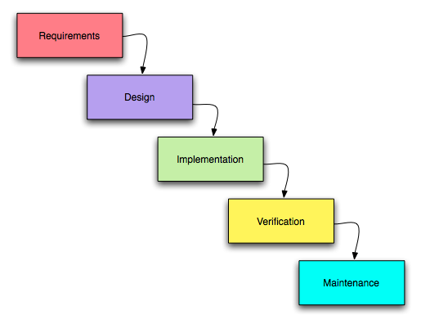

Despite the model being easy to understand and simple, the model is not ideal due to its inflexibility of not allowing changes to be implemented. Moving backwards in a phase is difficult, and the delivery of the final product will only be available towards the end of the cycle because there is no prototype. As such, the risk factor is on the high side. Testing can only be done towards the later stage in the cycle making it difficult to identify and assess the possible challenges and risks. Therefore, with the various disadvantages listed, the team will not be adopting the waterfall model for this project.

### 5.2.2 Agile

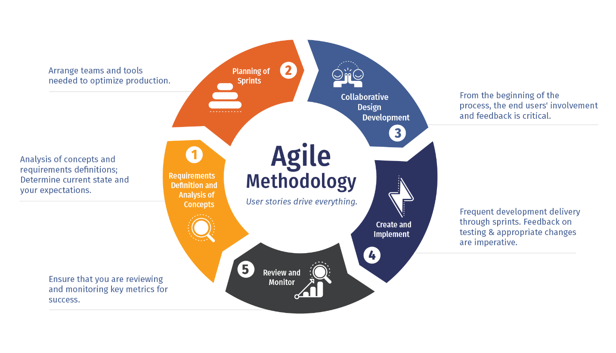

The Agile software methodology was developed to improve upon existing software development processes which were more complex. The aim was to speed up the processes and create a more efficient working model for teams.

The Agile software methodology was founded on four key values. These are:

1. Individuals and interactions over processes and tools

This means that the focus should be on the team, and emphasises that communication plays a key role in developing a product. When more people interact with each other and share their ideas, they build better products.

1. Working software over comprehensive documentation

The agile practices improved on other software development methodology which resulted in teams creating exhaustive documentation with technical specifications and requirements. These documents had to be prepared before developers started to write code, which would delay the software development process. Agile improves on these by streamlining these documents and condense these information into user stories. These stories equip the developer with all the details they need to start working on the software.

1. Customer collaboration over contract negotiation

Agile highlights the importance of customer collaboration. When bringing customers into the development process and getting their opinions and feedback, the development team can gain a deeper understanding of what the user really wants from the application being built.

1. Responding to change over following a plan

Another main difference Agile differs from traditional methodologies is that it advocates for change in the software development process. With Agile teams mostly working in short, iterative cycles, it believes that changes in the software development process can lead to better products.

Following the above four values, Agile methodology is said to bring about the following benefits. These are:

1. Satisfied Customers
2. Improved quality
3. Adaptability
4. Predictability
5. Reduced risk
6. Better communication

As a team, we have chosen the Scrum framework that uses the Agile methodology. The scrum methodology has 3 main areas that help with decision making:

1. Product Backlog - a list of functionalities of the product, prioritised by the business needs
2. Sprint Backlog - work to be done in a sprint based on the items chosen from the product backlog
3. Increment - the sum of all the tasks, use cases, user stories, product backlogs and any element that was developed during the sprint

The scrum methodology allows tasks to be split in short, iterative cycles known as sprint. Functionalities chosen to be developed in each sprint would be based on priority to the business. At the end of every sprint, the team can look back on the work done, and determine the next items to be included in the next sprint. This allows the team to periodically keep track of the application development progress, which helps in achieving a working product by the end of this project.

## 5.3 Risk Analysis

|  |  |  |  |  |
| --- | --- | --- | --- | --- |
| **Risk Category** | **Identified Risk** | **Impact** | **Probability Risk** | **Rating** |
| Communication | Communication between the team and stakeholders should be established and maintained at all times. | H | L | M |
| Maintenance | Application should be functional and bug-free. | H | L | M |
| Resources | Application should be compatible on the platforms listed for various stakeholders’ usage. | L | L | L |
| Security | All user information must be stored safely and Application shall not be compromised at all times. | M | M | M |
| Technical | Application unable to achieve project requirements | H | L | M |
| User | Requirements from Stakeholders must be interpreted accurately as to warrant met requirements. | H | L | M |

## 5.4 Project Schedule

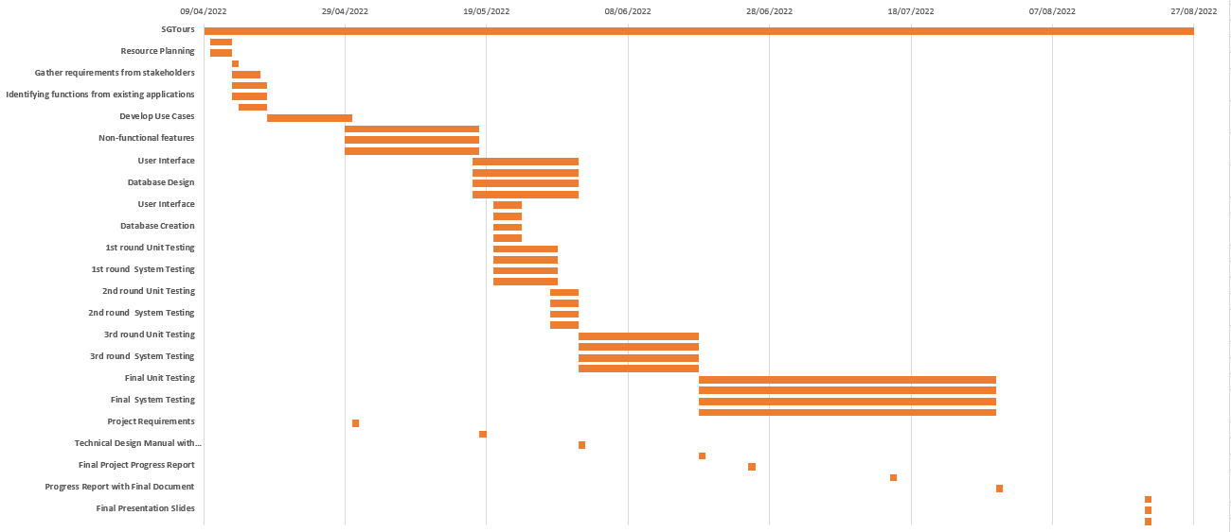

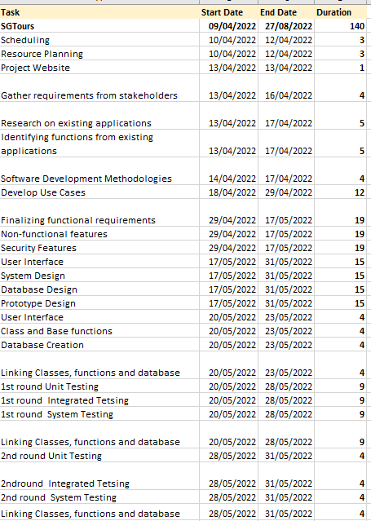

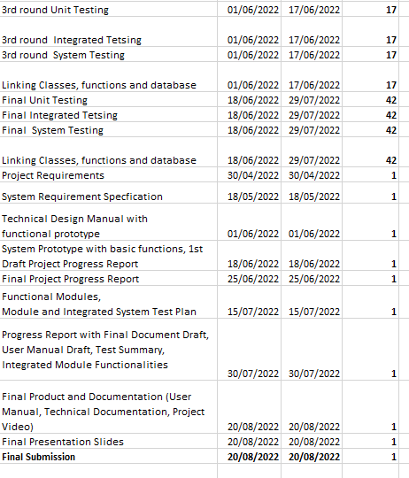

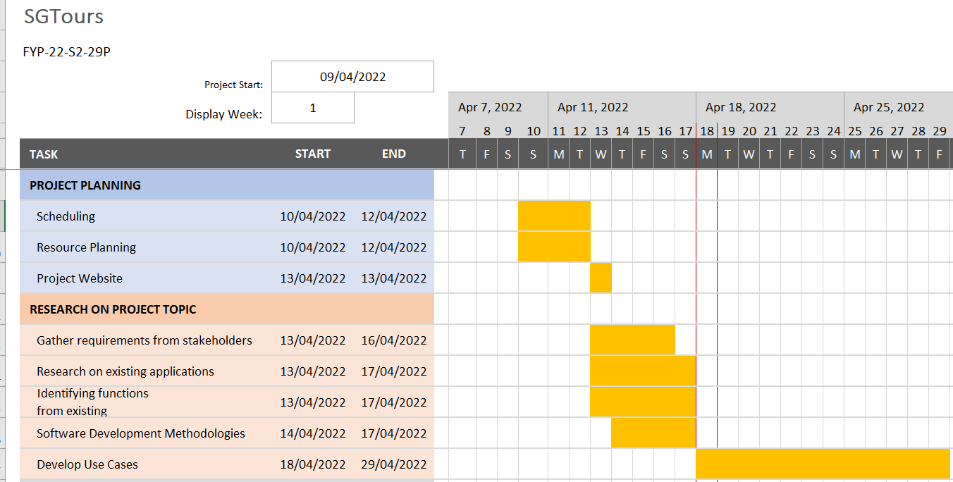

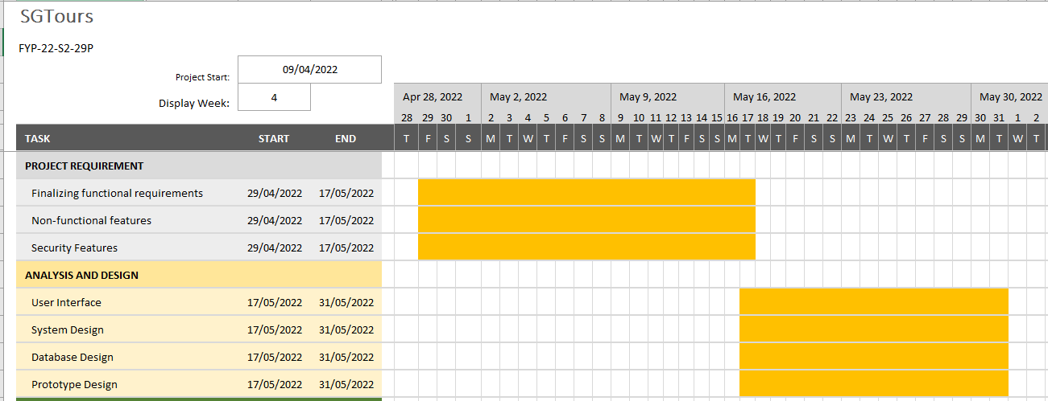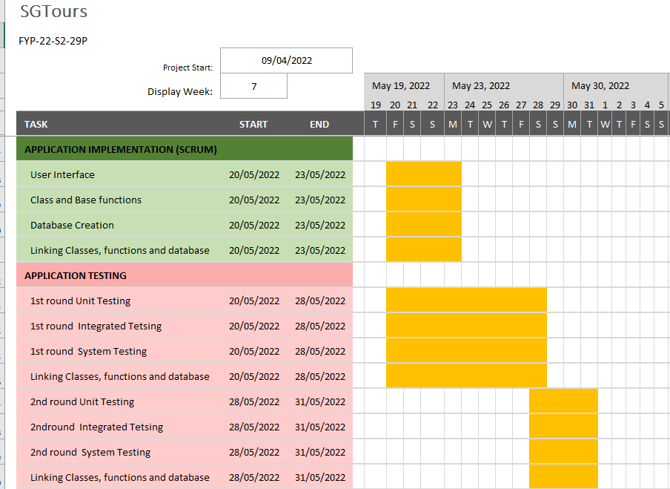

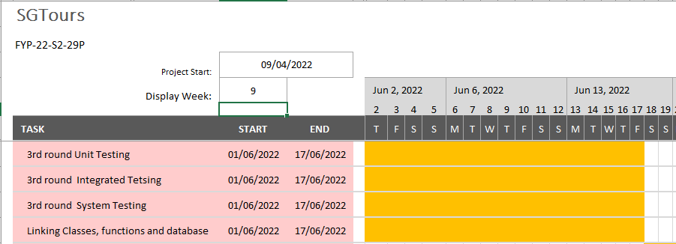

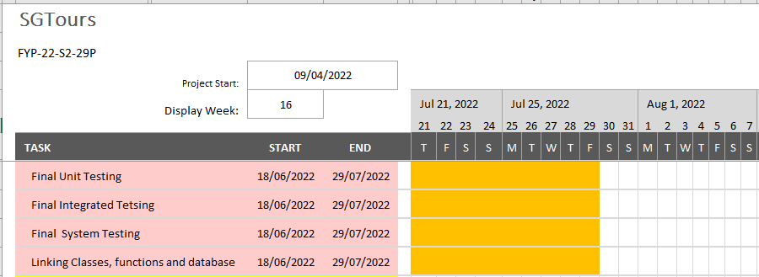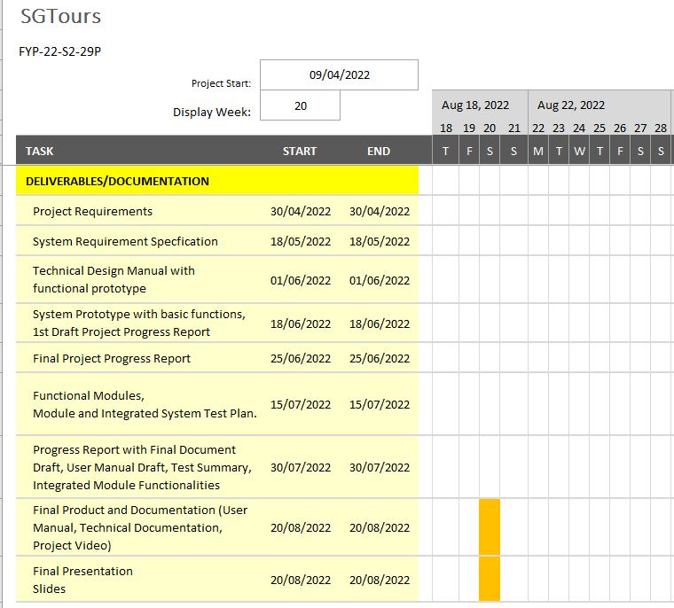

## 

# **Roles and Responsibilities**

|  |  |  |  |  |  |
| --- | --- | --- | --- | --- | --- |
|  | Chong Hui Wen | Chen Jingguo | Ho Bing Yuan | Viswanadham Udaya Chitanya Krishna | Wong Teck Yong |
| Project Manager | ✔ |  |  |  |  |
| System Analyst |  | ✔ |  |  |  |
| UI Designer | ✔ |  |  | ✔ | ✔ |
| Test Designer |  |  | ✔ |  |  |
| Application Tester |  |  | ✔ | ✔ | ✔ |
| Database Designer | ✔ | ✔ |  |  |  |
| Backend Developer | ✔ | ✔ | ✔ | ✔ | ✔ |

# **Development Tools**

## 7.1 Flutter

Flutter is an open-source UI software development kit created by Google.

It is used to develop cross platform applications for Android, iOS, Linux, macOS, Windows, Google Fuchsia, and the web from a single codebase.

**Pros:**

Flutter is easy to use and quick to learn as you can create fully functional apps with significantly less code. Its framework ensures a quick and simple installation that takes around 30 minutes, at which point we can build our first Flutter application.

Flutter uses Dart language, and both Flutter and Dart are open-source, which allow us free access to the original code and all the documentation that we will need. Its documentation is also user-friendly and easy to navigate, making it quick and simple to find answers to our questions.

Flutter has a feature called ‘Hot Reload’, which allows us to make changes to the back-end and observe the front-end changes instantly, decreasing the need to reload the entire application frequently. It would save us valuable development and compilation time.

**Cons:**

As Flutter uses Dart language, we are required to learn it as none of us are familiar with this language. Also, Flutter-built applications are relatively big, which would take up quite some space on IOS/Android devices.

**Programming Language Used:**

Dart Language

As stated in the pros of Flutter, it is easy to use and quick to learn as both Flutter and Dart language are open source.

We want to ensure that we can create a prototype fast so that we can correct any changes if needed. Hence, choosing Flutter will allow us to save up some time as it is stated in the pros, it is easy to use and quick to learn. At the same time, Flutter and Dart language are open source, which will allow us to search for any solution for any problems we face during the development phase.

## 7.2 Firebase

In order to help developers, build better real-time applications, Google acquired firebase in 2014, a backend development software, that offers a number of services, including, analytics, authentication, cloud messaging, real-time database, crashlytics, performance and test lab.

**Pros:**

* Unlike traditional relational databases, Firebase Realtime Database is a NoSQL database that uses JSON format to store data.
* Changes in data are reflected immediately across all platforms and devices within milliseconds.
* Internal cache that allows offline support
* Integrates well with Flutter.
* Free basic plan

**Cons:**

* Limited querying and indexing
* Uses JSON to store data, not easy to migrate
* Need to pay if hosting huge amount of connection

As projected that SGTours will not require a high level of use, Firebase is a good choice for a database as it is free to use. The ability to reflect new changes in data also allows users of SGTours to get real time updates, which is a huge advantage in today’s technology world. As well as it supports flutter integrations. Thus, the team has concluded to use Firebase Realtime Database as the database for SGTours application.

## 7.3 Others

We made use of UMLet - UML Diagram Editor to facilitate the creation of use case diagrams as it is relatively simple to use and user friendly.

The Team also made use of the Microsoft Office Package for the documentation. For instance, the team made use of Visio in the creation of the functional hierarchy, showcasing the functions proposed for the functional requirements isolated during the research. Excel was used to create the Gantt Chart, providing an overview of the timeline throughout this entire project.

As the team wanted a repository that could monitor changes while collaborating on the same file during the project phase, Github serves as an excellent platform with many resources available. As such, the team will make use of Github to store all relevant documents and the fact that it is open-source makes it easier for the team to work with. Github also allows integration and works with many different languages, along with the fact that it provides documentation, allowing the team to keep track of the changes made so far. As such, the team’s decision to utilise such tool.

# **Expected Results**

At the end of the project, the team hopes to achieve a fully functional application that provides not only seamless integration of maps, not only integrate existing functionalities that tourism applications available in the market contain, but also include functionalities that are refreshing and enticing to the users. The team also hopes to eliminate any frustration that arises while using such said applications.

# **Conclusion**

In conclusion, the team hopes to make a mobile application that will tap on existing resources and add on new functionalities. Convenience and seamless integration is what the team aims to achieve. With the functionalities discussed above in this document, the team is confident that the proposed functionalities will enhance the user experience.

Thank you for your kind consideration.

# References

Djermanović, D., n.d. *Introduction to Firebase Realtime Database.* [Online]   
Available at: https://www.raywenderlich.com/books/saving-data-on-android/v1.0/chapters/12-introduction-to-firebase-realtime-database  
[Accessed 17 April 2022].

DOIT Software ©, 2022. *Flutter vs. Kotlin in 2022: Which Is Best for Cross-Platform App Development?.* [Online]   
Available at: https://doit.software/blog/flutter-vs-kotlin-which-is-best-for-cross-platform-app-development  
[Accessed 18 April 2022].

DOIT Software, 2022. *Flutter vs React Native in 2022: Which One is Better for Your Project?.* [Online]   
Available at: https://doit.software/blog/flutter-vs-react-native  
[Accessed 18 April 2022].

Gaba, I., 2022. *Agile Vs Waterfall: Choosing the Best Methodology.* [Online]   
Available at: https://www.simplilearn.com/tutorials/agile-scrum-tutorial/agile-vs-waterfall  
[Accessed 19 April 2022].

Google LLC, n.d. *Firebase Realtime Database.* [Online]   
Available at: https://firebase.google.com/docs/database  
[Accessed 18 April 2022].

Guriev, B., 2021. *Firebase Pros and Cons: When You Should and Shouldn’t Use Firebase | OSDB.* [Online]   
Available at: https://osdb.io/firebase-pros-and-cons-when-you-should-and-shouldnt-use-firebase-osdb/  
[Accessed 17 April 2022].

Rosencrance, L., n.d. *Google Firebase.* [Online]   
Available at: https://www.techtarget.com/searchmobilecomputing/definition/Google-Firebase  
[Accessed 17 April 2022].

SOFTWARETESTINGHELP 2022, 2022. *What Is SDLC Waterfall Model?.* [Online]   
Available at: https://www.softwaretestinghelp.com/what-is-sdlc-waterfall-model/  
[Accessed 19 April 2022].

Wrike, Inc, n.d. *The Benefits and Advantages of Agile.* [Online]   
Available at: https://www.wrike.com/agile-guide/benefits-of-agile/  
[Accessed 19 April 2022].